SKELETAL SYSTEM

There are 206 bones in the human skeleton, which is made up of two general parts.

Axial Skeleton

• Made up of the skull, vertebral column, bones of the chest cavity (ribs).
• Protects the vital organs - the brain, the spinal cord, sense organs such as the eyes and
nose.

Appendicular Skeleton

• Made up of the arms and legs, as well as the bones that connect them.
• Provides support for the arms and legs to allow movement to occur.

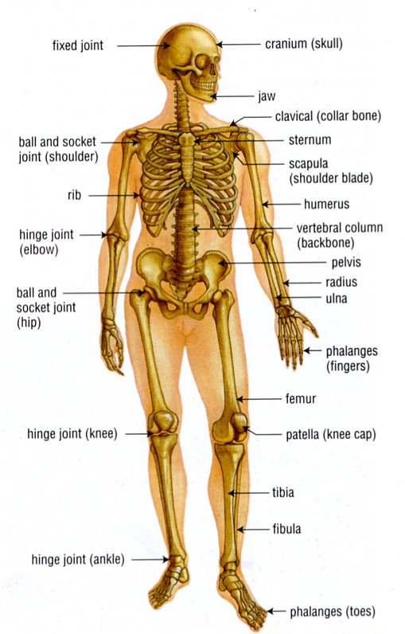

The bones in vertebrates are very strong and are made up of two types of bone:

• Compact bone - very dense and on the outside of a bone.
• Spongy bone - light and has a honeycomb appearance; found in the middle of a bone.

In the middle of a long bone (such as the femur - thigh bone) is marrow, which is involved in making red blood cells for the body.

Cartilage is found at the end of bones and allows the bones to move past each other with minimal friction. It is also found in joints, including discs between vertebrae in the spine; at the ends of ribs; and a few other places such as the nose and ears.

Types Of Joints

The bones in joints are held together by strong cords called ligaments. Ligaments are attached to
the bone and stop the bones from coming apart.

Joints are formed where bones meet to allow you to move, twist and bend. The range of movement depends on the type of joint. If a joint is twisted too far or pulled out of place the ligaments may tear, causing a sprain or dislocation.

There are several different types of joint.

• Sliding joints - allow side-to-side and back-and-forth movement.

e.g. Between vertebrae along the backbone.

• Pivot joints - allow the bones to rotate, causing a side-to-side movement

e.g. Found between the cranium (head) and the top of the spine - allows the head to
turn from side to side.

• Ball and socket joints - allows movement in most directions.

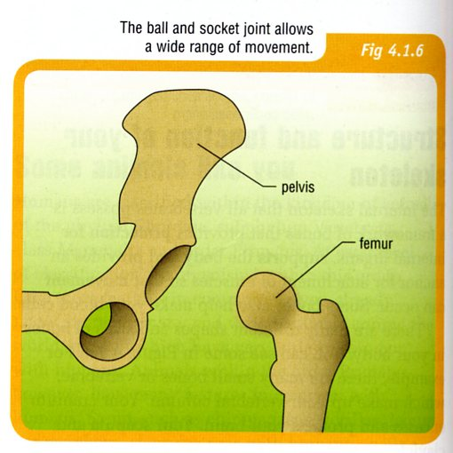
e.g. The shoulder and hip.

• Hinge joints - allow only back-and-forth
movement.

e.g. The fingers, toes, knees and elbows, which
involves bending and straightening.

In the joint is a cushion of fluid called synovial fluid, which lubricates the joint and acts as a shock absorber to protect the bones during movement.

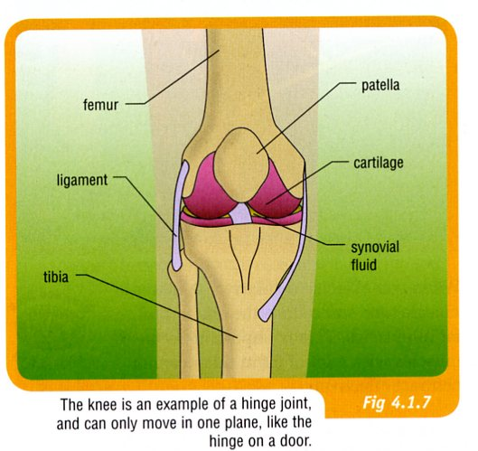

Muscles

Muscles contract and relax to make bones move. There are two types of muscles:

• Voluntary - muscles that can be controlled by a person.

e.g. Muscles of the arms and legs.

• Involuntary - muscles that can't be controlled by "thought"; the subconscious part of the
brain does this automatically.

e.g. Internal organs such as heart, lungs, digestive system and circulatory system.

Muscles may be long and thin, in flat sheets, arranged in layers or in any other shape needed to carry out the function. There are three different types of muscle tissue.

• Striated muscle - controls most voluntary movement by the skeleton, and is often
called voluntary muscle.

• Cardiac muscle - controls the actions of the heart.

• Smooth muscle - controls most involuntary muscle actions.

Voluntary muscles usually work in pairs, with one contracting and the other relaxing. This is because muscles cannot push on bones and can only work through pulling. When a muscle contracts it becomes shorter and fatter.

e.g. The biceps and triceps muscles of the upper arm work together to bend and straighten
the arm.

